
Data Wrangling

🔹 Reminder
Yesterday we cleaned the Titanic dataset (handled missing values, duplicates, datatypes).
👉 Today we’ll transform it so it becomes usable for insights and analysis.

🔹 Notes on Data Wrangling
- Definition → Data wrangling is the process of transforming raw data into a structured, usable format.
- Why important?
  - Raw datasets are messy.
  - Analysis/ML requires tidy data (rows = observations, columns = features).
  - Enables pattern discovery and insights.
Common Wrangling Operations:
- Filtering → Selecting specific rows.
- Grouping → Summarizing by categories.
- Merging → Combining datasets.
- Pivoting → Reshaping data.
📌 Use in Data Science: Wrangling prepares datasets for visualization, dashboards, and machine learning models.

🔹 Filtering
Practical
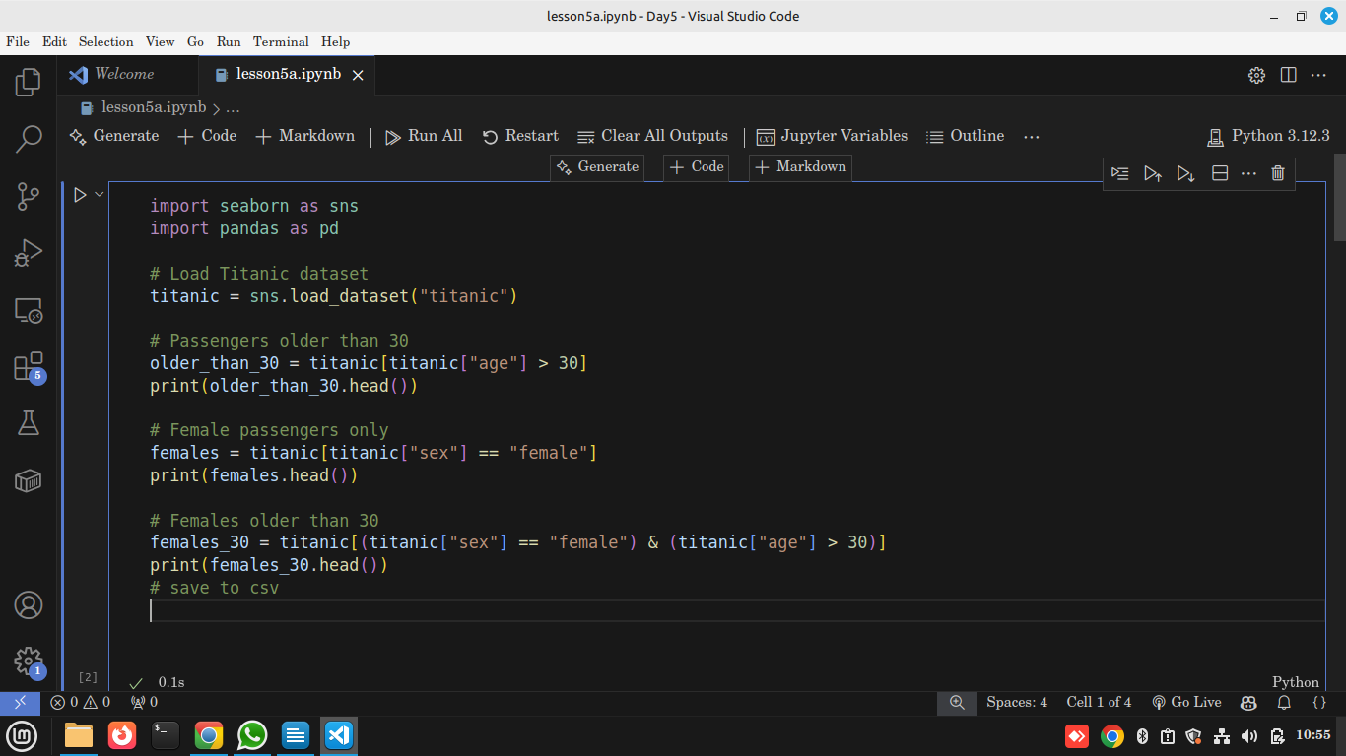
Sample output
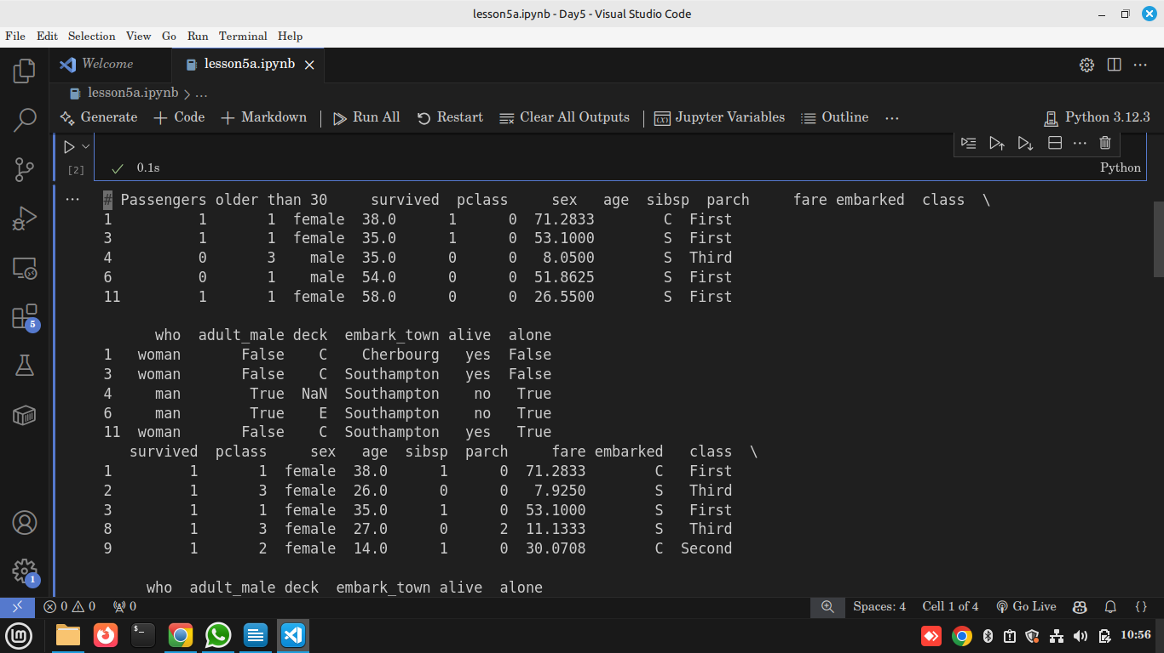

Explanation
- df[condition] → selects rows matching condition.
- & = AND, | = OR.
- Used for subsetting datasets.
Use in Data Science → Filtering helps analysts zoom in on specific groups (e.g., “Find customers over 40 in Nairobi with purchases > $500”).

🔹 GroupBy & Aggregations

Practical
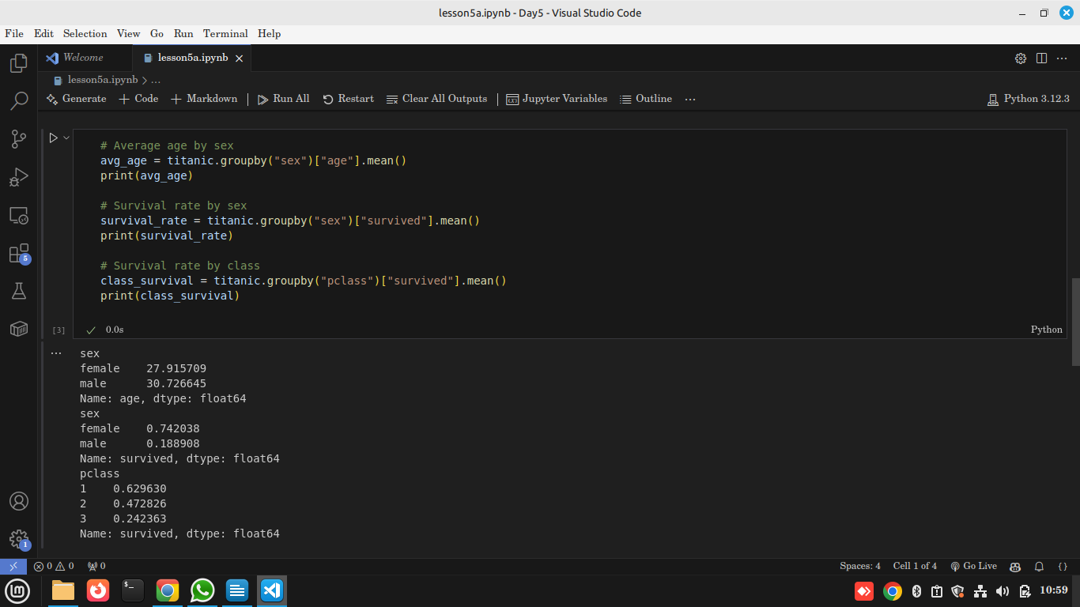
Explanation
- groupby() → splits data into groups.
- .mean(), .sum(), .count() → applies aggregation.
Use in Data Science → GroupBy helps compare segments (e.g., “average salary by department”, “churn rate by subscription plan”).

🔹 Merge & Join

Practical
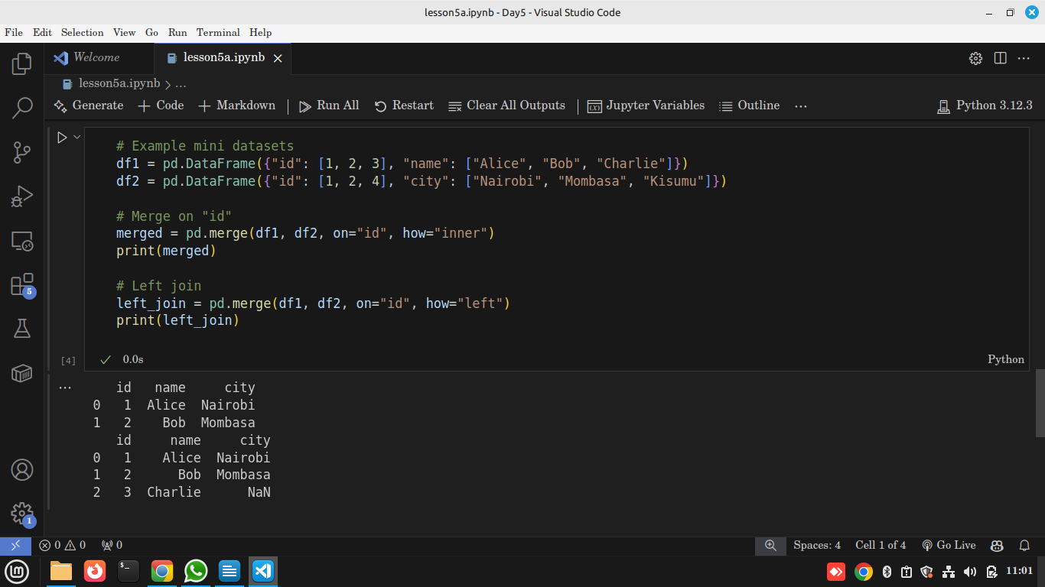
Explanation
- pd.merge() combines datasets by keys (like SQL joins).
- Types → inner, left, right, outer.
Use in Data Science → Merging combines info from multiple sources (e.g., transactions + customer demographics).

🔹 Pivot Tables
Practical
Explanation
- Pivot tables reorganize data to show summaries across two dimensions.
- Example → Survival rate by sex and passenger class.
Use in Data Science → Pivot tables simplify comparisons (like Excel pivot tables for quick insights).

🔹 Mini Challenge
👉 On Titanic dataset:
- Filter passengers under 18.
- Group by class and calculate survival rate.
- Pivot survival rates by sex and class.

🔹 Reflection
- Wrangling transforms raw data into analysis-ready datasets.
- Without wrangling, you can’t do visualization or ML.
- Which operation felt most powerful today? (Filtering, GroupBy, Merge, Pivot).

